Assignment-4.3 AIAC
Batch No:-25
Roll No:-2303A51632

SCHOOL OF COMPUTER SCIENCE AND ARTIFICIAL INTELLIGENCE |  |  |  |  | DEPARTMENT OF COMPUTER SCIENCE ENGINEERING
Program Name: B. Tech |  |  |  | Assignment Type: Lab |  |  | Academic Year:2025-2026
Course Coordinator Name |  |  |  | Dr. Rishabh Mittal
Instructor(s) Name
  Mr. S Naresh Kumar
  Ms. B. Swathi
  Dr. Sasanko Shekhar Gantayat
  Mr. Md Sallauddin
  Dr. Mathivanan
  Mr. Y Srikanth
  Ms. N Shilpa
  Dr. Rishabh Mittal (Coordinator)
  Dr. R. Prashant Kumar
  Mr. Ankushavali MD
  Mr. B Viswanath
  Ms. Sujitha Reddy
  Ms. A. Anitha
  Ms. M.Madhuri
  Ms. Katherashala Swetha
  Ms. Velpula sumalatha
  Mr. Bingi Raju
Course Code |  |  | 23CS002PC304 | Course Title |  | AI Assisted Coding
Year/Sem |  |  | III/I | Regulation |  | R23
Date and Day  of Assignment |  |  | Week 2 - Wednesday | Time(s) |  | 23CSBTB01 To 23CSBTB52
Duration |  |  | 2 Hours | Applicableto  Batches |  | All batches
Assignment Number: 3.3(Present assignment number)/24(Total number of assignments)
 | Q.No. | Question |  |  |  |  |  | Expected Time  to complete
 | 1 | Lab 4: Advanced Prompt Engineering – Zero-shot, One-shot, and Few-shot Techniques  Lab Objectives  - To explore and apply different levels of prompt examples in AI-assisted code generation  - To understand how zero-shot, one-shot, and few-shot prompting affect AI output quality  - To evaluate the impact of context richness and example quantity on AI performance  - To build awareness of prompt strategy effectiveness for different problem types  Lab Outcomes (LOs)  After completing this lab, students will be able to:  - Use zero-shot prompting to instruct AI with minimal context  - Use one-shot prompting with a single example to guide AI code generation  - Apply few-shot prompting using multiple examples to improve AI responses  - Compare AI outputs across different prompting strategies  Task 1: Zero-Shot Prompting – Leap Year Check  Scenario  Zero-shot prompting involves giving instructions without providing examples.  Task Description  Use zero-shot prompting to instruct an AI tool to generate a Python function that:  - Accepts a year as input  - Checks whether the given year is a leap year  - Returns an appropriate result  Note: No input-output examples should be provided in the prompt.  Expected Output  - AI-generated leap year checking function  - Correct logical conditions  - Sample input and output  - Screenshot of AI-generated response (if required)  Prompt:-  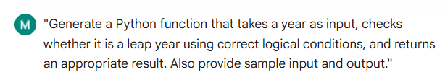  Code:-  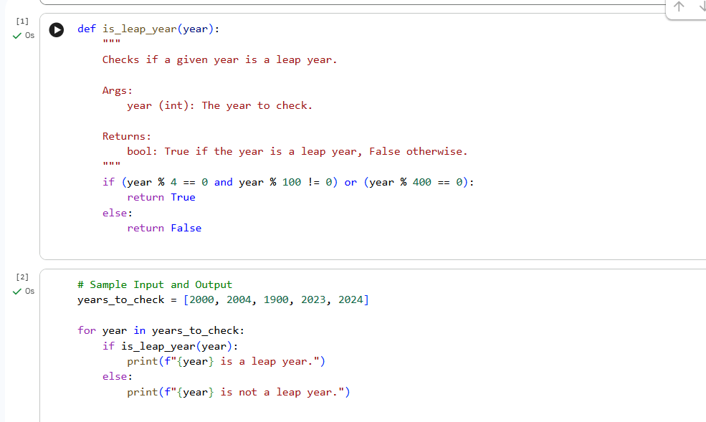  Output:-  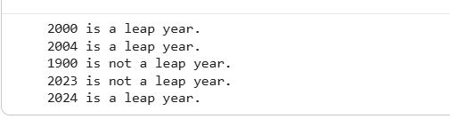  Explanation:-  It checks whether a given year is a leap year or not. It uses a function called is leap year that applies simple rules to decide if a year is a leap year. If the year satisfies the conditions, the function returns True; otherwise, it returns False. The program then tests this function using some example years and prints the result for each one. It shows how to use functions, conditions, and loops in Python in an easy way.  Task 2: One-Shot Prompting – Centimeters to Inches Conversion  Scenario  One-shot prompting guides AI using a single example.  Task Description  Use one-shot prompting by providing one input-output example to generate a Python function that:  - Converts centimeters to inches  - Uses the correct mathematical formula  Example provided in prompt:  Input: 10 cm → Output: 3.94 inches  Expected Output  - Python function with correct conversion logic  - Accurate calculation  - Sample test cases and outputs  Prompt:-  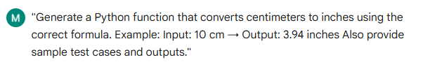  Code:-  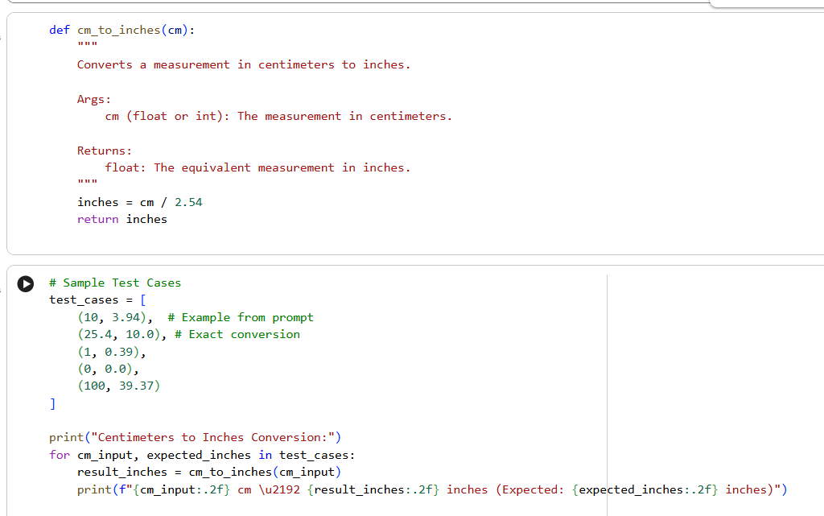  Output:-  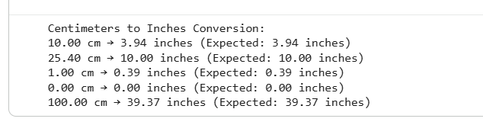  Explanation:-  The code creates a tool that changes centimeters into inches by dividing by 2.54. Then, it uses this tool on some example numbers to make sure it works correctly, showing both what it calculated and what it should have calculated.  Task 3: Few-Shot Prompting – Name Formatting  Scenario  Few-shot prompting improves accuracy by providing multiple examples.  Task Description  Use few-shot prompting with 2–3 examples to generate a Python function that:  - Accepts a full name as input  - Formats it as “Last, First”  Example formats:  - "John Smith" → "Smith, John"  - "Anita Rao" → "Rao, Anita"  Expected Output  - Well-structured Python function  - Output strictly following example patterns  - Correct handling of names  - Sample inputs and outputs  Prompt:-  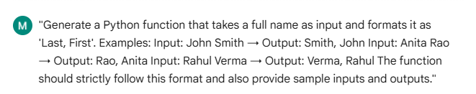  Code:-  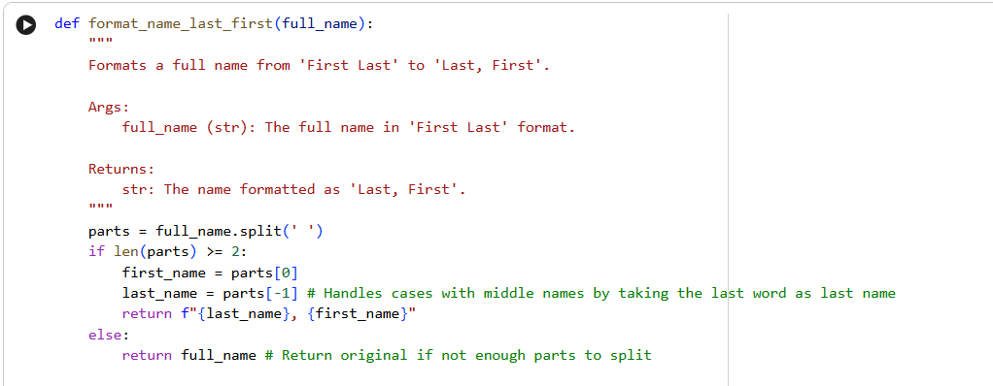  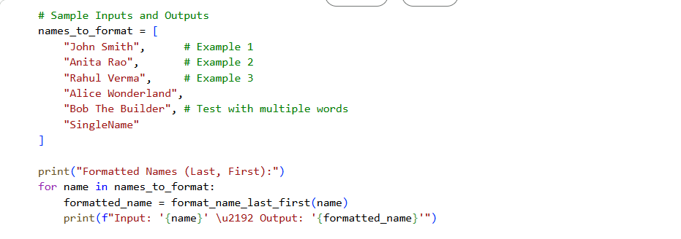  Output:-  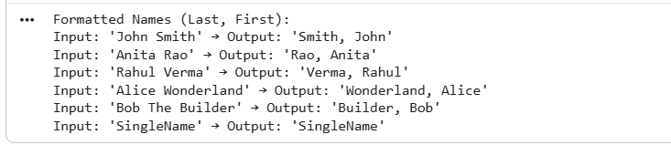  Explanation:-  This program converts a name from "First Last" to "Last, First". It first checks whether the input is a string. Then it splits the name into words and extracts the first and last words. It handles middle names by taking only the last word as the last name. It also uses exception handling to manage invalid inputs like numbers. The program tests different cases using a loop and prints formatted results.  Task 4: Comparative Analysis – Zero-Shot vs Few-Shot  Scenario  Different prompt strategies may produce different code quality.  Task Description  - Use zero-shot prompting to generate a function that counts vowels in a string  - Use few-shot prompting for the same problem  - Compare both outputs based on:  - Accuracy  - Readability  - Logical clarity  Expected Output  - Two vowel-counting functions  - Comparison table or short reflection paragraph  - Conclusion on prompt effectiveness  ZERO SHOT PROMPT:-  Prompt:-  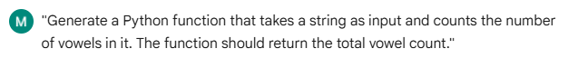  Code:-  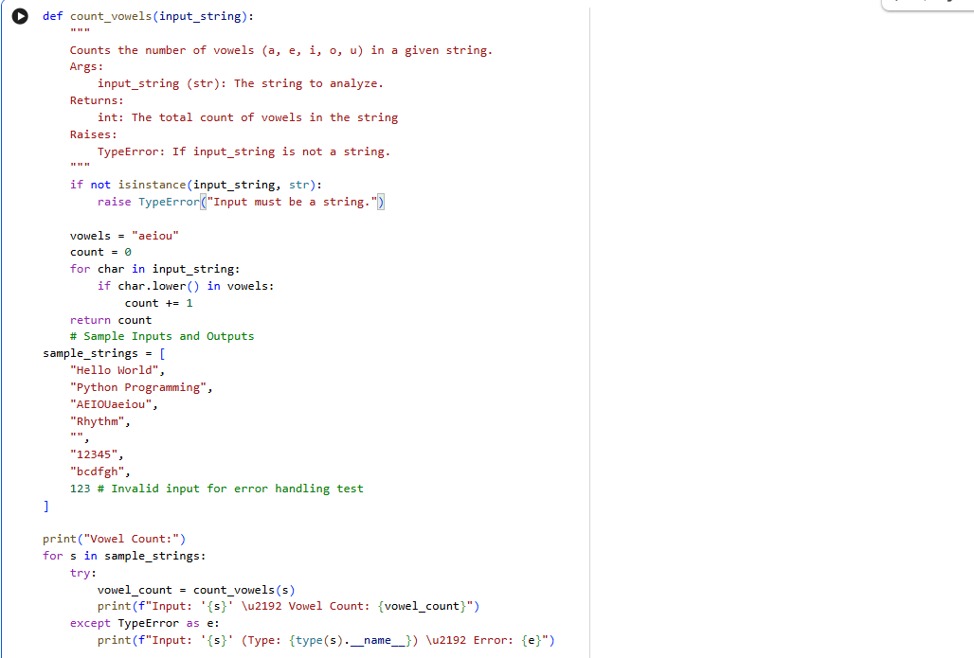  Output:-  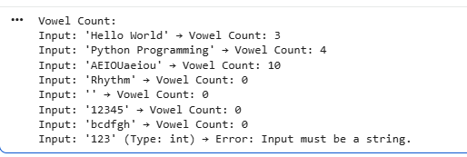  FEW SHOT PROMPT:-  Prompt:-  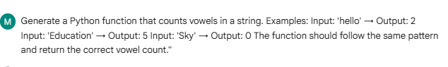  Code:-  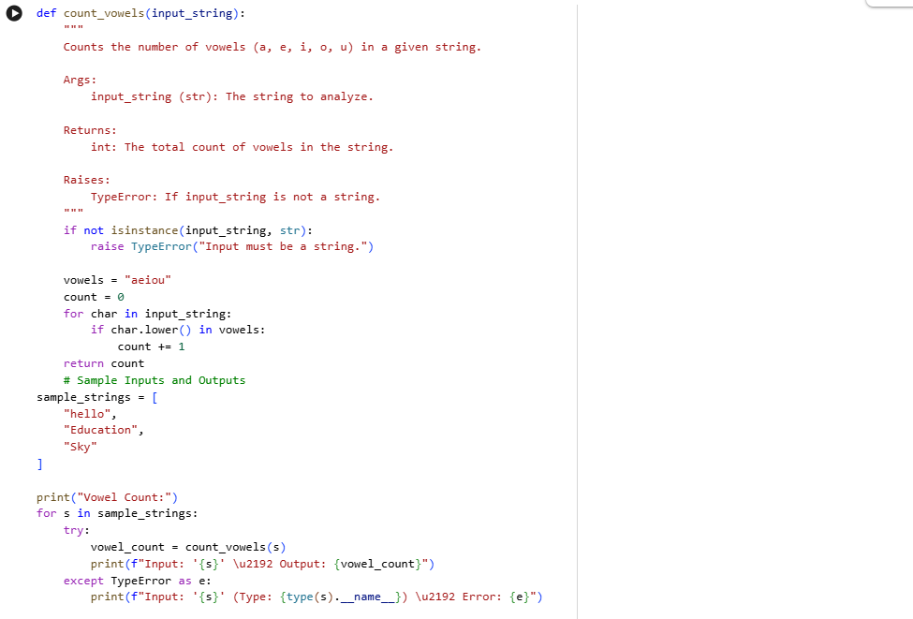  Output:-  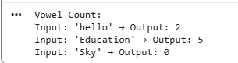  Reflection:-  Few-shot prompting produces better quality code compared to zero-shot prompting. Because examples are provided, the AI understands the required behavior more clearly. This results in more accurate and consistent logic. Zero-shot prompting depends only on instructions, so it may sometimes miss edge cases. Few-shot prompting improves reliability and clarity  Conclusion:-  Few-shot prompting is more effective than zero-shot prompting for generating accurate and well-structured code. The presence of examples helps the AI understand the expected output format and logic. Therefore, few-shot prompting is preferred when precision and consistency are required  Task 5: Few-Shot Prompting – File Handling  Scenario  File processing requires clear logical understanding.  Task Description  Use few-shot prompting to generate a Python function that:  - Reads a .txt file  - Counts the number of lines in the file  - Returns the line count  Expected Output  - Working Python file-processing function  - Correct line count  - Sample .txt input and output  - AI-assisted logic explanation  Prompt:-  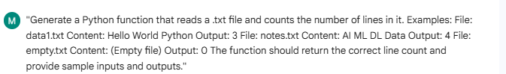  Code:-  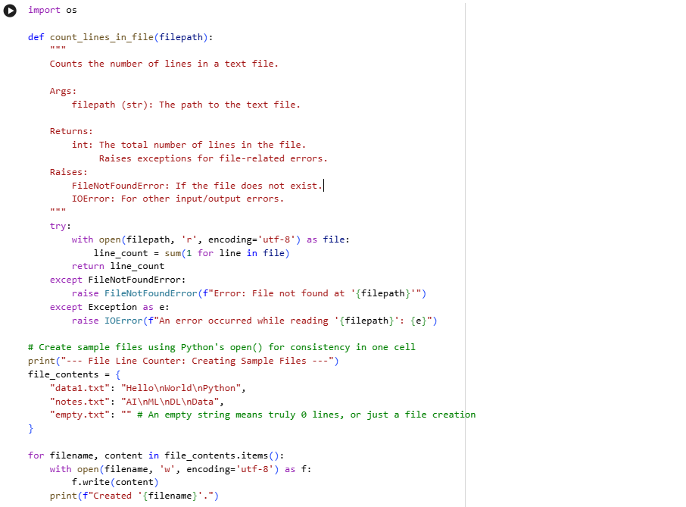  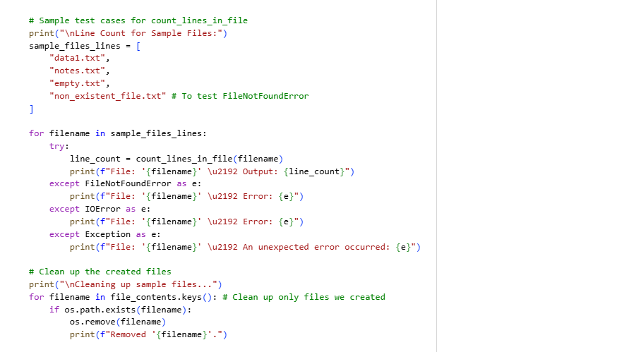  Output:  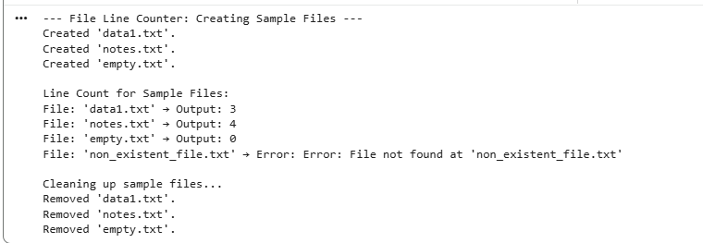-  Explanation:-  This counts the number of lines in a text file using Python. Firstly it defines a function that opens a file in read mode and counts each line using a simple loop method. It also uses error handling to show proper messages if the file is not found or if any other problem occurs while reading the file. Then, the program creates some sample text files with predefined content for testing. After that, it applies the line-counting function to each file and displays the result. If a file does not exist, an error message is printed instead of stopping the program. Finally, the created files are deleted to keep the system clean. This program demonstrates basic file handling, exception handling, and testing in Python.  Note: Report should be submitted as a word document for all tasks in a single document with prompts, comments & code explanation, and output and if required, screenshots. |  |  |  |  |  | Week2 - Wednesday

